MEMO

To: WV STARS Entity PD Providers

From: WV STARS

Date: 8/6/20

Re: Reminders About Entity Courses and New Location for Online Classroom Links

Dear WV STARS Entity PD Providers,

Hello!

I have a few reminders for Entity PD Providers that submit courses that will be under an Entity. There are 4 key differences you want to include with these submissions:

1. Instead of a person being the course owner, you want the Entity account. (This is automatic if you submit the course logged in under that account). You can search by the account’s number or type “Entity” in the last name line to find the Entity. Make sure to give anyone that needs them the necessary permissions to this course.

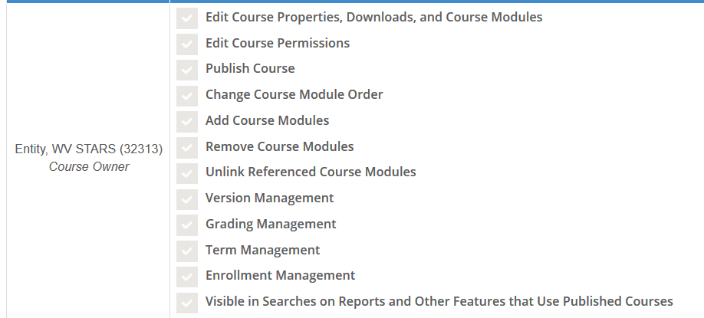

1. The course number should have the Entity abbreviation at the end instead of your registry id. (Example: SETrainerOrienation5hrWVSTARS instead of SETrainerOrienation5hr10036). If you don’t know the abbreviation, you can look at previously approved courses to see how it is formatted or email me.



1. You want the course provider to be the Entity as well.



1. You want to include the appropriate store front icon. All icons will be in a folder for the Entity, but just make sure to select the correct delivery format (face to face, webinar, facilitated, or self-paced). You can change it by going to “Select Image”, then find the folder for your Entity.

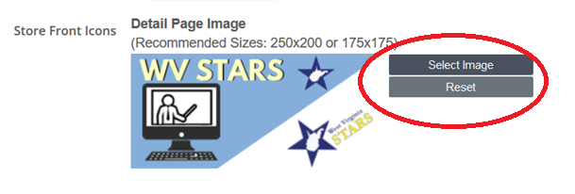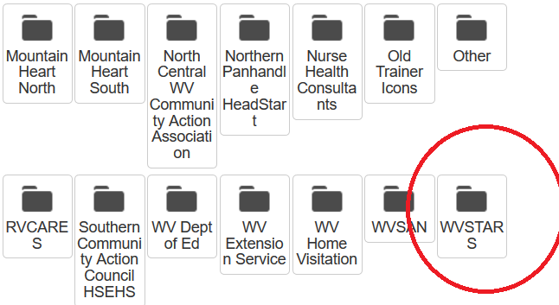

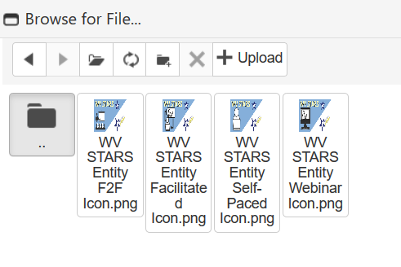

Lastly, for any courses that need a classroom through Go to Training/Meeting, these will now be under the “Online” location instead of the “TCR Go to Training” location. You still submit the classroom form to me so I can add them to our system. This form (titled “Classroom Form for Go to Training”) is under the “Professional Development Providers” section of the wvstars.org site under “Training Forms and Resources”.

If you have any questions, please let me know.

Thank you!